Melodic minds and rhythm sticks: the stories of disabled musicians

Participants wanted for a study of the experiences of disabled musicians!

Are you a musician with some form of impairment? If you are, I want to hear from you.

The study involves you taking part in an interview lasting around two hours.

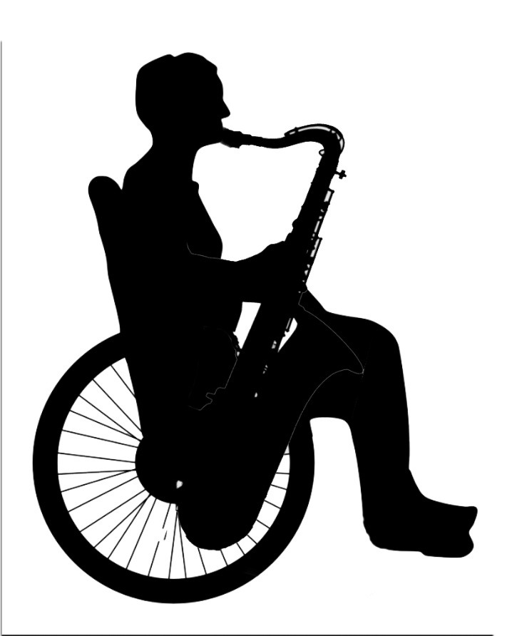

For more information, contact:

Nathaniel Ford-Francis

[ss17nff@leeds.ac.uk](mailto:ss17nff@leeds.ac.uk)

Recruitment closes at the end of December 2024.

This study has been approved but the Business, Environment, Social Sciences (BESS+ FREC) Committee, University of Leeds, on the 09/08/23. Ref: 066