|  |  |  |
| --- | --- | --- |
| Version 2 | 17/7/23 | Payment amounts checked  References to Zoom removed |

Information about the project

**This research project is about disabled musicians.**

Would you like to take part?

Before you decide it is important that you understand why I am doing this project.

Please read this booklet carefully. You can talk to other people about it if you would like to.

Please ask someone if there is anything you don’t understand. Please tell me if I have not explained something properly.

After you have finished, you can decide if you want to take part.

**Thank you for thinking about taking part in my project!**

1. Who am I?

2. What is the project about?

3. Why I you want you to take part?

4. Do you have to take part?

5. What will happen if you take part?

6. What will I ask you?

7. Will you be recorded?

8. Will taking part be good or bad for you?

9. Will I tell people what you say?

10. What will I do with what I find out?

11. Contact info

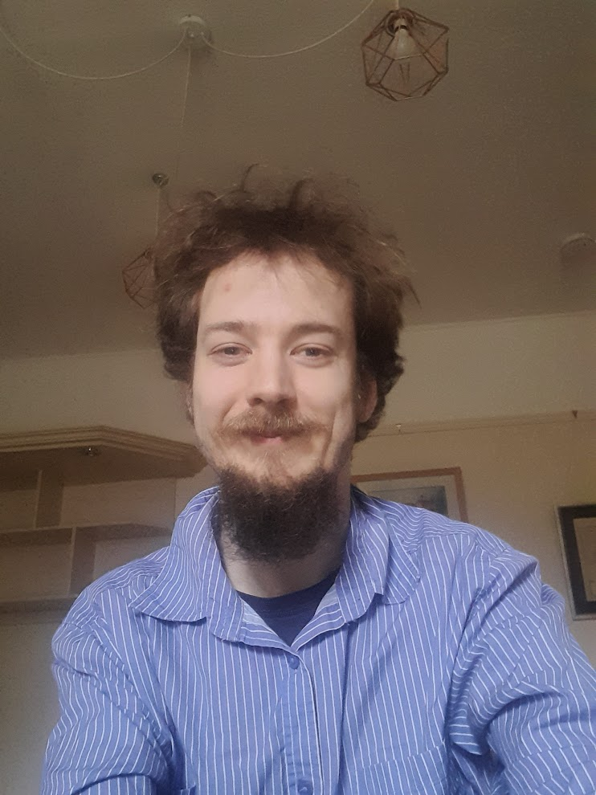 **Who am I?**

Hello! My name is Nathaniel. I am a research student at the university of Leeds. I am going to write a report (thesis), which I will give to the examiners, who will hopefully give me a ‘PhD’ qualification.

**What is the project about?**

I am looking at **Musicians with disabilities.**

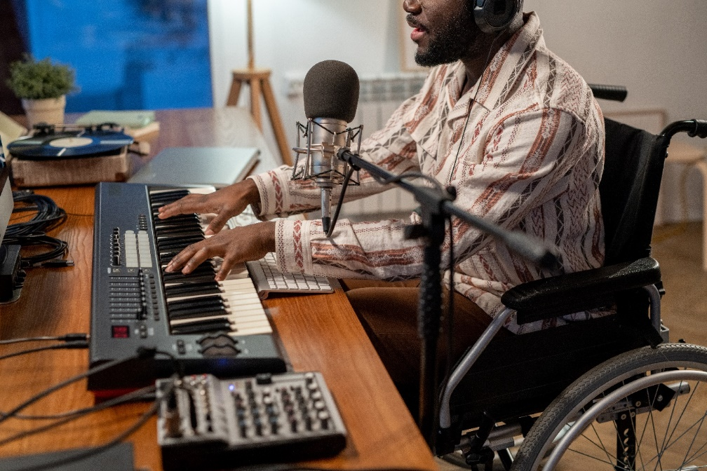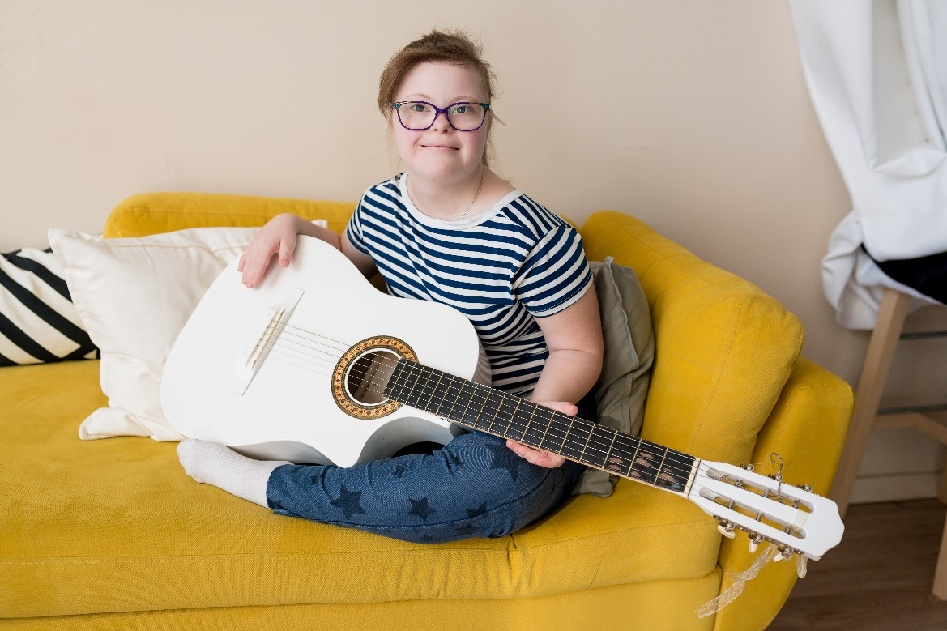

I am interested in the **stories** of how you started playing music and what has happened to you along the way.

**Why do I want you to take part?**



If you are a musician who has a disability, then I want to hear about your experiences. It does not matter **how** you make music (if you sing, play an instrument, use a computer or something else).

**Do I have to take part?**

NO

No. It is up to you. If you would like to take part. I will ask you to sign a sheet that checks you understand about taking part. If you change your mind, you can stop taking part at any time. You don’t have to tell me why if you don’t want to.

After the interview, you can **change your mind** up to **the end of September 2024**

**What will happen to me if I take part?**

I will visit you and ask you to tell me about how you’ve found playing music and the different things that have happened to you as a musician.



**Or,** I will ask you some questions on **Teams.**

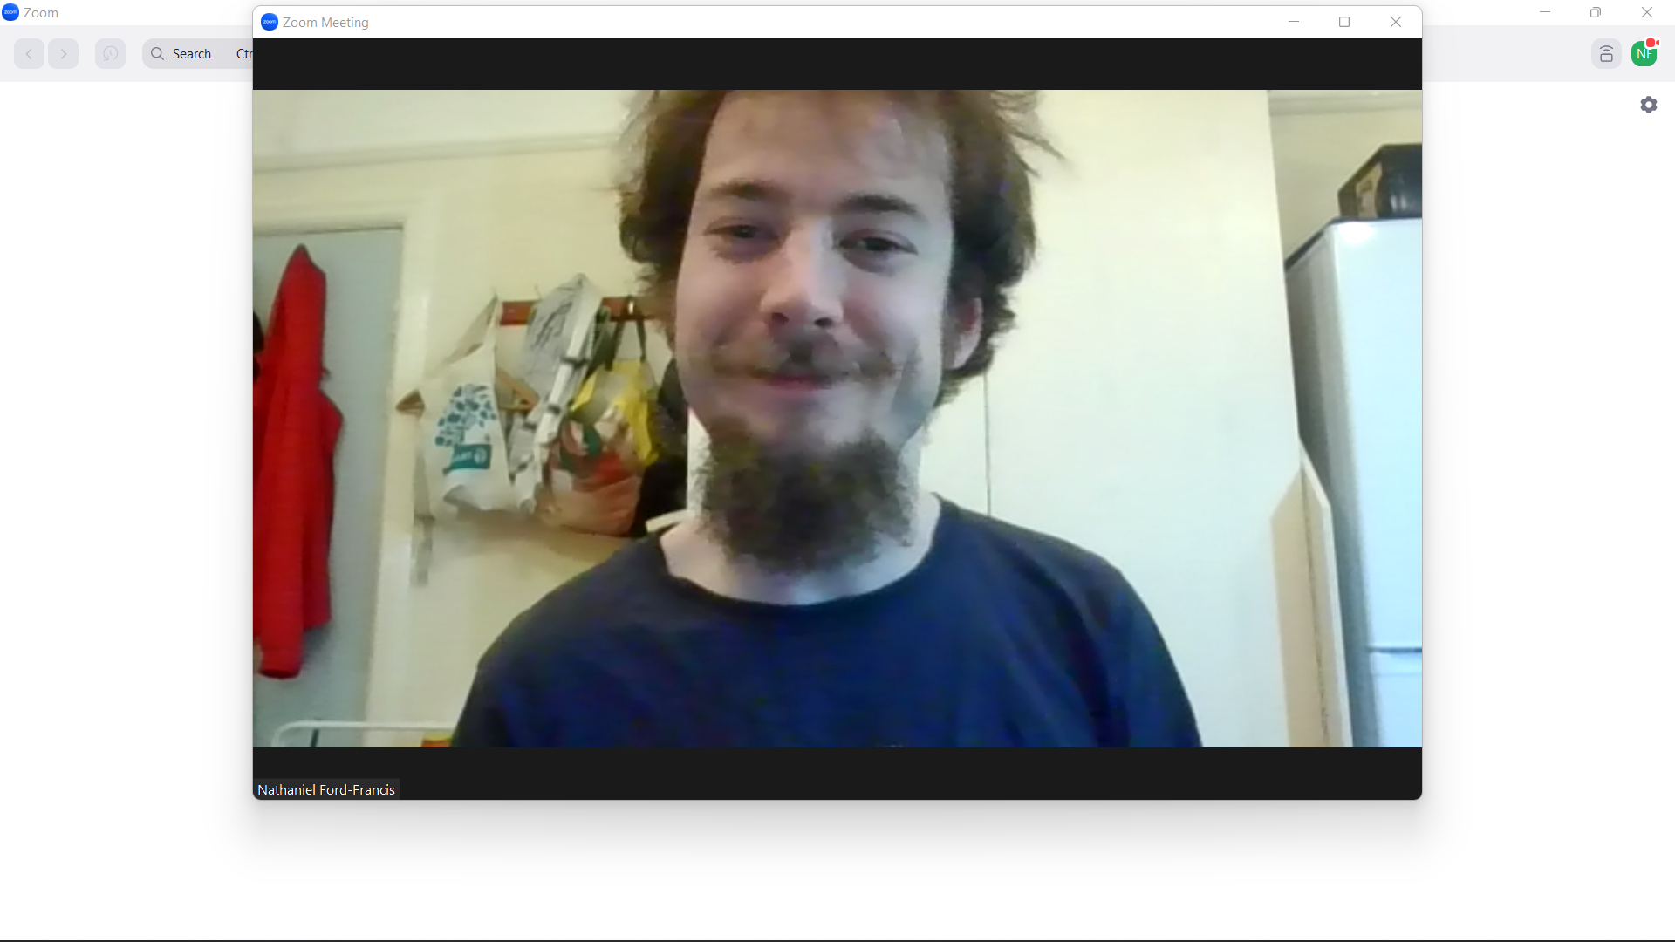

I will want you to tell me the **story** of how you started playing music and the things that have happened to you along the way.

You can view the legal information about what teams do with the information collected here:

<https://www.microsoft.com/licensing/docs/view/Professional-Services-Data-Protection-Addendum-DPA>

I might also **email** you afterwards with some more questions if I think of them.



**What will I ask you?**



I will want you to tell me the **story** of how you started playing music and the things that have happened to you along the way.

I will ask you questions to help you if you are not sure what sort of thing to say. If it helps, we can draw a picture (called a ‘life map’) of your story to make it clearer for both of us.

**Will you be recorded?**

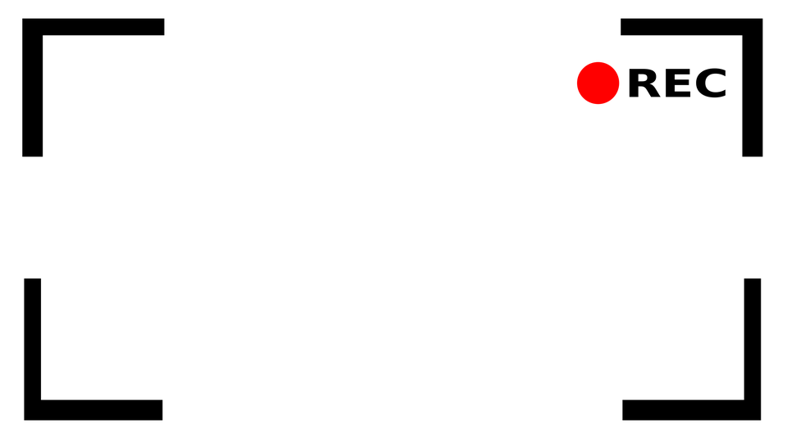

Yes. If you want to meet in person, I will make audio recordings of the interviews. If we do the interview on Teams, I will make video recordings. This is so that I do not forget anything that you have said. The recordings will be stored safely on university computers. No one will hear them except me.

**What happens to the recordings?**

I will save them onto my university OneDrive that only I have the **password** to get in to.

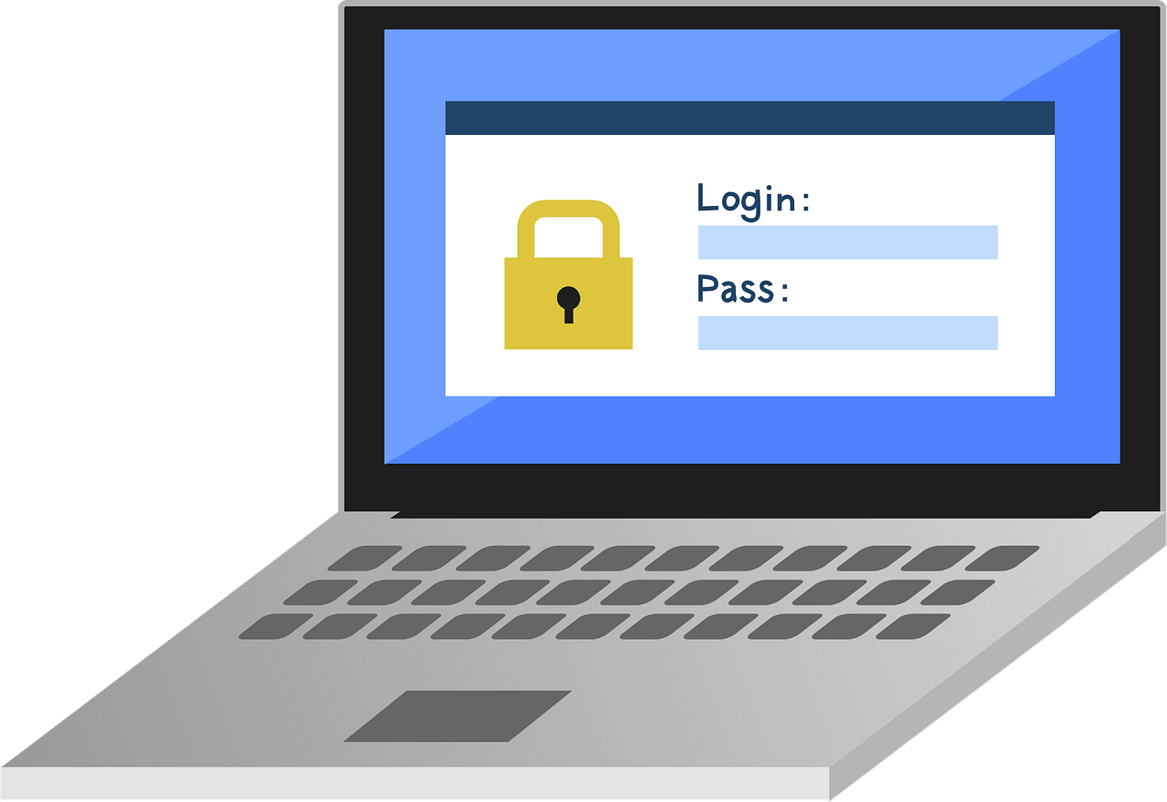

**Will I be named in the report?**

No. If I quote from you, I will change the name in the report.

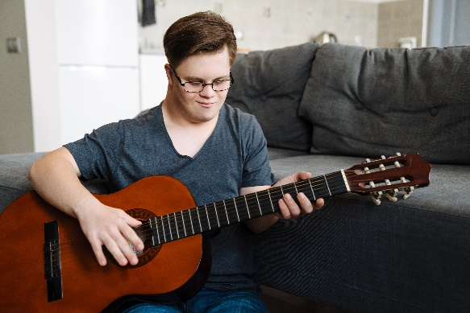 

**John**

**“Daniel”**

**Will taking part be good or bad for you? **

?

Talking about music is generally something that musicians like doing!

Plus, I will give you a ‘Thank you’ payment of £24 for your time.

**But**, telling a true story means giving me a lot of information about yourself. You might want to think if this is something you want to do.

I will change you name in the report but it is still possible that someone who knows you might read the report and recognise that it is you.

**What will I do with what I find out?**

I will use the information to write a report (thesis), which I will give to the university. I hope that they will give me a qualification called a PhD.



I also want to write an **article** for a journal, which is a sort of academic **magazine**, telling people what I have found out.



If they will let me, I would also like to publish a **Blog post** on ‘Disability arts online’ or similar places.



**If you agree**, I could also share a copy of the interviews with other researchers to help with other studies. Your name, the place where you live and so on will be taken out before I do this. **You do not have to agree to this to be part of the research**

**Want to get in touch?**

You can tell me that you want to take part or ask me questions by emailing me on [ss17nff@leeds.ac.uk](mailto:ss17nff@leeds.ac.uk)